Linux Server and London Bamboo Build
- Server and Account info
The Linux server is: adl-quant01. You can log into the machine using the “putty” tool, as shown below:

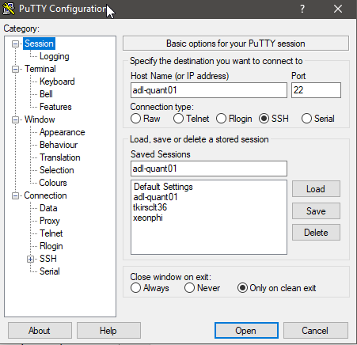

The Bamboo server logs into the Linux machine using the “plink” command, which is part of the putty install. “Plink” allows Bamboo to run a remote command on the Linux server. This remote command is in fact a script which builds everything and runs the tests.

- Account information
Bamboo uses these credentials to log into the Linux server:

svc_quant_dev / e4jPLezoetDi

If you need to check something on the Linux machine for some reason, you may log in using this account. But be careful not to leave any checked out files, or interfere with the Bamboo build.

- Build scripts
On the Linux server the build scripts are stored in the following directory (on Linux, folders are known as directories), outside of git:
/home2/svc_quant_dev/scripts
In particular, the main build and test script is:
svc_quant_dev_git_build_and_test.sh
This is the script which Bamboo runs via “plink”. The script returns an error code to report back whether the build succeeded or failed (exit 1). Bamboo also captures the log transcript of the build.
These Linux scripts are checked into git, and can be viewed in Windows in this folder:
%MLIBQ%\resource\utilities\BatchFiles\_GIT\BuildServer
- Linux workspace
The source code is checked out into the following workspace:
/workspace/svc_quant_dev/MLIBQ
The third-party dependencies are stored in:
/workspace/svc_quant_dev/library
- The main build command
If you look in the svc_quant_dev_git_build_and_test.sh script, you will see it runs these two main commands:

make -f Makefile.everything clean
make -f Makefile.everything -j8
The first command deletes all object files (*.o), static libraries (*.a) and executables (*.exe) from the build artifacts directory.
The second command actually performs the compilation by building each project in turn. The “-j8” flag means “try to run 8 build jobs at once”.
If the build succeeds, the script then runs this command:
./TestNinja.py --threads 8
This runs the python version of TestNinja, which runs GOOGLE_TEST with up to 8 tests running in parallel.
Note 1: At the top of the script there is a “source” command. This imports extra settings which allow us to use gcc 9.1.1.
Note 2: The script sets the MLIBQ variable as follows:
export MLIBQ=/workspace/svc_quant_dev/MLIBQ
Setting the MLIBQ variable allows GOOGLE_TEST.exe to find the resource directory and in particular the resource/config directory.

- Build artifacts directory
The output from running a build is stored in this directory:

/workspace/svc_quant_dev/MLIBQ/src/lib
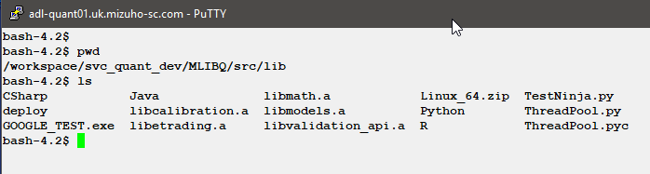
a) In the screenshot we see the subfolders CSharp, Java, Python, R. These contain the MLIB_CLIENT_API libraries and config for each of the supported languages.
b) We also see libcalibration.a, libmath.a, libmodels.a, libetrading.a, libvalidation.a. These are the static libraries for each project, equivalent to the windows “lib” files.
c) There is also GOOGLE_TEST.exe, which is the compiled GOOGLE_TEST binary.
d) Finally there is TestNinja.py, which is the python version of TestNinja which allows us to run tests in parallel. It makes use of ThreadPool.py which contains a thread scheduler. The ThreadPool.pyc is a byte-code compiled python file which is generated on the fly when running the python code.
e) Those with eagle eyes will notice the deploy folder. This is a staging area containing the language APIs and GOOGLE test. There is also the file Linux_64.zip, which is a zipped up version of the deploy folder. This is the file which Bamboo copies to the release folder on the X: drive.

- Running GOOGLE_TEST.exe manually
Before running GOOGLE_TEST.exe, first make sure the MLIBQ variable is set correctly, using the “export” command as shown in the screenshot below:

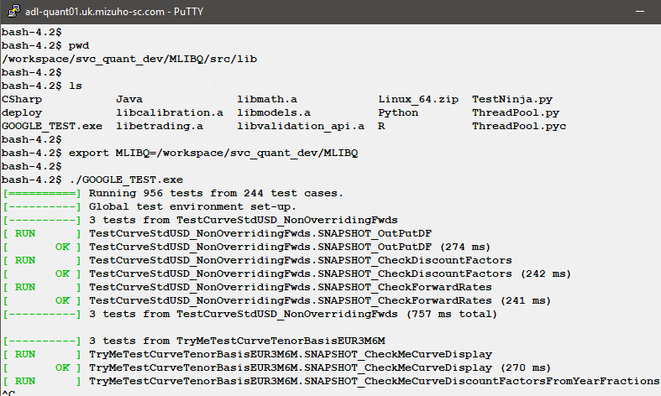

You can stop GOOGLE_TEST by pressing ctrl-c.

- Running TestNinja.py manually
Similar to GOOGLE_TEST, first make sure the MLIBQ variable is set correctly, using the “export” command as shown in the screenshot below:

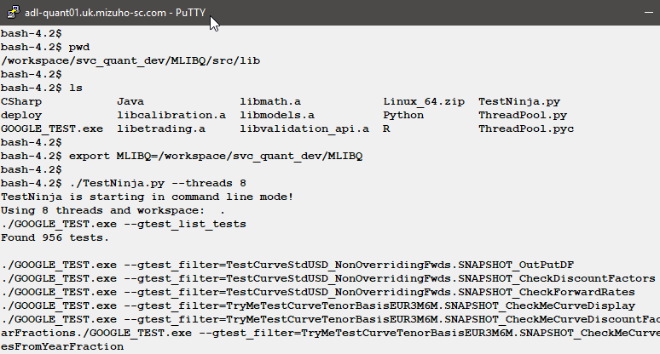

You can stop TestNinja by pressing ctrl-c

